# Regional mapping of Spekboom canopy cover using very high resolution aerial imagery

# Abstract

Very high resolution canopy cover maps of Spekboom are required to assist with restoration of degraded habitat in the Little Karoo, a large semi-arid region in South Africa. Relatively few studies have assessed the application of high resolution remote sensing for monitoring vegetation over large areas, especially in arid regions. Variations in habitat and level of degradation, in addition to radiometric variations in the imagery, make vegetation mapping at a regional scale a challenging problem. In this article we present a per-pixel classification approach for canopy cover mapping of Spekboom using multi-spectral 0.5m resolution aerial imagery, comprising 2228 scenes covering a 5893 km2 area. The imagery was radiometrically homogenised with a novel technique that uses satellite data to convert digital numbers to estimated surface reflectance values. A feature clustering and ranking procedure that is robust to feature redundancy was applied to select an informative feature subset from a typical set of spectral, textural and vegetation index features. Support vector machine (SVM), random forest, decision tree, K-Nearest Neighbour (kNN) and Bayes normal classifiers were evaluated against hand labelled pixel data and canopy cover ground truth acquired at 20 field sites. The results showed that all the classifiers, except the Bayes normal classifier, performed well. The decision tree produced the best results compared to the in situ canopy cover data. It produced a mean absolute canopy cover error of 5.85% with a standard deviation of 4.65%.

## Index Terms: Very high resolution, aerial imagery, vegetation mapping, classification, radiometric homogenisation, feature redundancy

# Introduction

Spekboom (*Portulacaria afra*) is an evergreen succulent tree growing to 2.5m, with a dense canopy of small fleshy leaves. It occurs in the Subtropical Thicket biome in the semi-arid Eastern Cape and Little Karoo regions in South Africa (Vlok, Cowling, and Wolf 2005). “The Subtropical Thicket habitat types are most easily recognized by the occurrence of woody trees, spinescent shrubs and a relative abundance of succulents. When occurring as solid stands the vegetation can form impenetrable dense thickets, but this is uncommon in the Little Karoo. In most of the area the Subtropical Thicket vegetation occurs as discrete bush-clumps, usually in a matrix of Succulent Karoo vegetation” (Vlok, Cowling & Wolf 2005: 41). While Spekboom is tolerant of browsing by indigenous herbivores, it is highly susceptible to over browsing by goats (Marais, Cowling, and Powell 2009; Sigwela et al. 2009; Mills et al. 2007; Mills et al. 2005). Poorly managed goat grazing has transformed thicket over much of its range into sparsely scattered thicket clumps, isolated trees and a covering of herbs (Mills et al. 2005).

Restoration of degraded thicket habitat is beneficial from a number of perspectives. Spekboom is unusually effective at storing carbon in arid regions (Mills et al. 2005). Subtropical Thicket provides an important source of food for many herbivores, including domesticated livestock (Thompson et al. 2009; Vlok, Cowling, and Wolf 2005). Re-establishment of Spekboom in degraded areas will reduce erosion, reduce flood severity and improve water quality (van Luijk et al. 2013; Mills and Cowling 2006). Restoration of Spekboom is also attractive from an employment perspective; potentially creating thousands of jobs in impoverished areas, if implemented on a large scale.

Currently, the most practical option for thicket ecosystem restoration is through the planting of Spekboom cuttings (Mills et al. 2007; Vyver et al. 2012). Spekboom acts as a nurse plant and facilitates the creation of a favourable environment for the spontaneous recruitment of other plants (Adie and Yeaton 2013; Mills and Cowling 2010).

Spekboom canopy cover maps are required to assist in the restoration process. There is a need for greater accuracy and repeatability than is possible with field based mapping techniques. Field mapping is time consuming and costly and is not practical over large areas (Eisfelder, Kuenzer, and Dech 2012; Powell 2009; Lu 2006). The impracticality of manual field mapping is confounded in the Subtropical Thicket biome due to its density (inaccessibility), heterogeneous nature and complex growth forms (Powell 2009).

Thompson et al. (2009) conducted a general degradation mapping study of the biomes occurring in the Little Karoo. A 1:50000 vegetation map developed by Vlok, Cowling & Wolf (2005) was used to delineate different habitats so they could be treated separately. A coarse three level degradation classification of Subtropical Thicket was derived by thresholding 250m resolution MODIS NDVI data. The study was successful at estimating three degradation levels (intact, moderate and severe) of Spekboom thicket at the 250m MODIS resolution.

Currently, there is an initiative to involve private land-owners in Subtropical Thicket restoration in order to broaden its impact (Curran et al. 2012; Mills et al. 2010). Spekboom is to be planted in stand sizes as small as three hectares on these lands. VHR maps are required to provide sufficient spatial detail for accurately monitoring canopy cover in these small planting stands. High spatial resolution imagery is also necessary to facilitate discrimination of small Spekboom clumps from the complex and varying mosaic vegetation in which it occurs. To achieve sufficient accuracy for carbon storage estimations, it will be necessary to estimate canopy cover in finer detail than the three levels of degradation and250m resolution used in Thompson et al. (2009).

Multi-spectral VHR imagery has been successfully used for vegetation mapping in a number of studies. A combination of spectral, vegetation index, band ratio and textural features are commonly used to provide informative measures capable of distinguishing vegetation classes (Basu et al. 2015; Ghosh and Joshi 2014; Johansen et al. 2007; Kollár, Vekerdy, and Márkus 2013; Mustafa and Habeeb 2014). Object based approaches to image classification, where homogenous image objects are first segmented and then classified as a whole, have become popular in vegetation studies (Kollár, Vekerdy, and Márkus 2013; Ouyang et al. 2011; Ghosh and Joshi 2014). These approaches are often favoured for VHR imagery (Basu et al. 2015; Ghosh and Joshi 2014; Johansen et al. 2007; Kollár, Vekerdy, and Márkus 2013; Mustafa and Habeeb 2014; Ouyang et al. 2011) because they are potentially able to better exploit the additional spatial information and deal with unwanted variation when compared to the more traditional per-pixel approach (Ouyang et al. 2011; Ghosh and Joshi 2014). The segmentation problem is however recognised as being poorly posed, requiring manual adjustment of parameters and being difficult to solve robustly (Baraldi et al. 2010). Per pixel classification provided good and useful mapping accuracy in a number of studies (Boyden et al. 2007; de Castro et al. 2012; Mehner et al. 2004) and is a simpler and faster method, not requiring user specification of algorithm and associated parameters. .

A variety of supervised approaches are used for classification of features derived from VHR imagery. Some authors found the Bayes normal (maximum likelihood (ML)) classifier to adequately model their class distributions (Boyden et al. 2007; de Castro et al. 2012; Mehner et al. 2004). Others adopted more sophisticated approaches such as support vector machines (Ghosh and Joshi 2014) and neural networks (Basu et al. 2015; Mustafa and Habeeb 2014). Algorithms implemented in the eCognition software package (Trimble 2016) , such as the fuzzy and hierarchical approaches, are also frequently used for VHR image classification (Johansen et al. 2007; Kollár, Vekerdy, and Márkus 2013; Ouyang et al. 2011).

As the number of features increases, the amount of data required to adequately represent class distributions in the increased feature space increases exponentially. This is known as the “curse of dimensionality” (Bishop 2003). For finite training samples, increasing the features beyond a certain point results in overtraining and a decrease in the classifier’s ability to generalise. This “peaking phenomenon” (Jain, Duin, and Mao 2000) makes it necessary to apply feature selection to reduce the size of the feature set to a salient minimum in order to achieve an accurate classifier. Feature selection by ranking based on some separability or importance measure of individual features is frequently used (Basu et al. 2015; Johansen et al. 2007; Kollár, Vekerdy, and Márkus 2013). While fast, feature ranking is known to be sub-optimal for feature spaces containing redundancy (Tolosi and Lengauer 2011). Ghosh and Joshi (2014) used recursive feature elimination (RFE) (also known as backward elimination); a greedy search technique to select informative features. Of the reviewed studies, this was the only one to use a feature selection method that considers the effect of feature redundancy by evaluating features in combination.

The majority of the reviewed vegetation mapping studies were applied to small areas, typically covered by a single satellite image (Boyden et al. 2007; Ghosh and Joshi 2014; Johansen et al. 2007; Kollár, Vekerdy, and Márkus 2013; Mehner et al. 2004; Ouyang et al. 2011). Radiometric corrections are sometimes ignored for small study areas (Boyden et al. 2007) or partially handled using conversion to top of atmosphere (TOA) radiance (Johansen et al. 2007; Mehner et al. 2004). These corrections do not compensate for varying atmospheric and bi-directional distribution function (BRDF) effects that are characteristic of datasets containing hundreds or thousands of aerial images. (Bradski 2000)

In this paper, we present a method for mapping Spekboom canopy cover at a spatial resolution of 0.5m. A total of 2228 multi-spectral aerial images acquired over multiple days from 22 January to 8 February 2010 were used as input. Radiometric variations due to - atmospheric and BRDF effects in the images were reduced using a simple yet effective technique for homogenising the digital numbers to surface reflectance. This not only allowed for the application of a single classification algorithm on the entire set of images, but also provides the possibility of extending the presented mapping technique spatially and temporally. An informative feature subset was selected from a typical set of spectral, vegetation index and textural features using a novel feature selection method that is robust to redundancy typically found in high dimensional feature sets. The selected features were used to evaluate a set of candidate classifiers. (Bradski 2000)

# Methods

## Study Area

The Little Karoo is a semi-arid region of great biodiversity located in the Western Cape Province of South Africa (Figure 1). The Subtropical Thicket biome makes up 35.3% of the 23439 km2 area (Vlok, Cowling, and Wolf 2005). A total of 54 habitat types are present, of which ten support Spekboom (Vlok, Cowling, and Wolf 2005). It is estimated that about 90% of the Spekboom thicket in the area is degraded to some extent A 5893 km2 (25%) representative portion was chosen as the study area, as shown in Figure 1. This area includes nine of the ten habitat types supporting Spekboom.

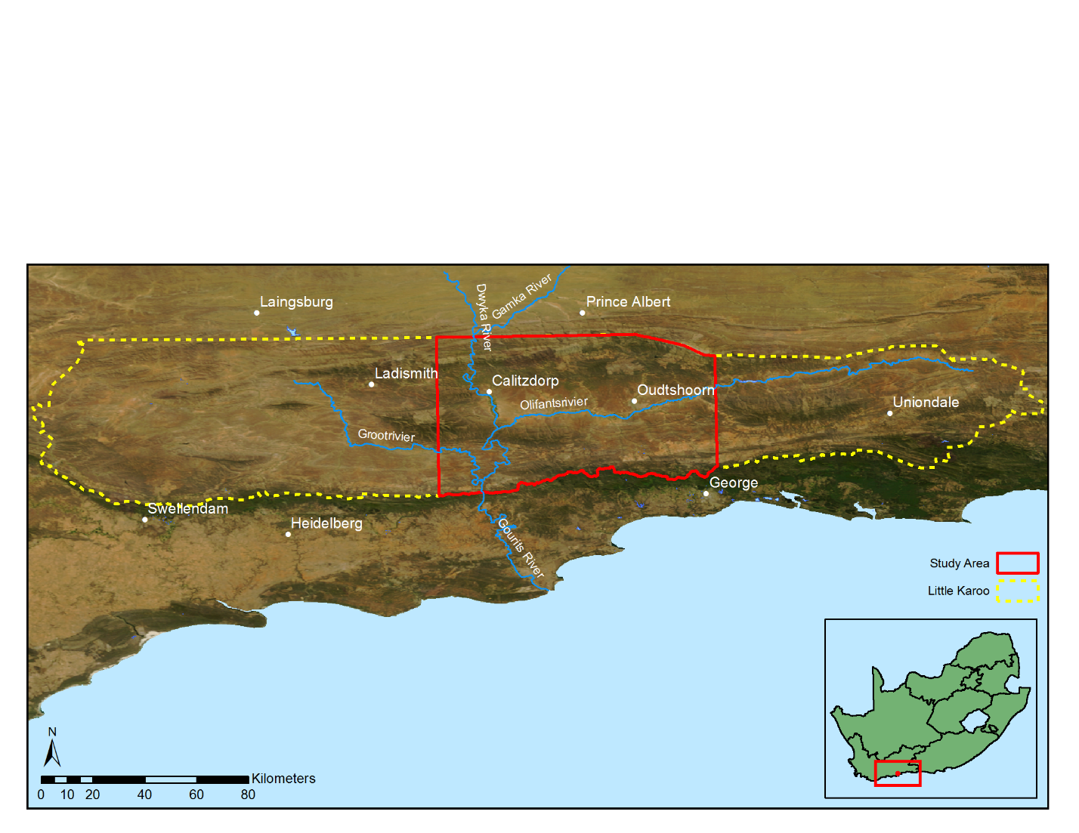

Figure 1 Little Karoo study area

## Imagery

VHR aerial imagery of the study area was acquired from Chief Directorate: National Geo-spatial Information (NGI), a component of the South African Department of Rural Development and Land Reform. The images were captured at a 0.5m resolution with an Intergraph Digital Mapping Camera (DMC) which provides multi-spectral red, green, blue and near-infrared (NIR) bands. The study area is covered by 2228 images acquired over multiple days from 22 January to 8 February 2010 which is during the area’s dry season. e dry season imagery While the imagery provided by NGI is orthorectified, it has no radiometric corrections applied to it. The NGI imagery contains variations due to BRDF and atmospheric effects which make it poorly suited to quantitative remote sensing techniques. The imagery was consequently radiometrically homogenised by applying a technique for surface reflectance estimation by calibration with satellite data. This technique corrects for coarse scale atmospheric and BRDF effects using a well-calibrated surface reflectance satellite image as a reference. We used a MODIS MCD43A4 composite image for the period from 25 January 2010 to 9 February 2010 for this purpose. This image has a 500m resolution and contains nadir BRDF-adjusted reflectance (NBAR) data composited from the best values over a 16 day period. Further details of the technique and its application to the study area can be found in Chapter 2. Radiometric correction is important for our study as it allows accurate snapshot mapping over a large spatial extent and provides the possibility of repeating the canopy cover mapping over time to evaluate restoration progress.

## Mapping Methodology

The image resolution of 0.5m, combined with the tendency of Spekboom to grow in continuous stands, meant that there was little spectral mixing and pixels covering Spekboom were relatively pure. This supported a per-pixel classification approach to distinguish Spekboom from the surrounding vegetation. The pixel based approach also allowed the complexities associated with segmentation to be avoided. The fractional canopy cover was determined as the portion of pixels classified as Spekboom over an area of interest.

,was anRadiometric homogenisationthe GDAL (GDAL Development Team 2014) and OpenCV (Bradski 2000) software

## Data Collection

Two datasets were constructed: one for evaluating the canopy cover estimates obtained from the classifier outputs and a second for training and evaluating the classifier on a per-pixel basis. The first data set consisted of in situ estimates of canopy cover acquired at 20 different sites, each of roughly one hectare. A botanist with experience in the area provided expertise in the selection of sites to encompass variation in geology, habitat and level of degradation. Boundary polygons, were recorded for each site by walking the perimeter with a DGPS device. The DGPS coordinates were post-processed to provide about 30cm accuracy. Estimates of canopy cover inside the site perimeters were made during the field visits. The locations of the ground truth sites and their corresponding area names are shown in Figure 2. Details of the surrounding (“mosaic”) vegetation type, geology and estimated canopy cover for each site are given in Table 1. A three level degradation measure, as used in Thompson et al. (2009), is reported for each site. This data set is referred to as the “in situ canopy cover data” and was used for evaluating the accuracy of canopy cover estimates obtained from the classifier output. Figure 3 shows an example of a site perimeter on a background of the NGI imagery, rendered in RGB.

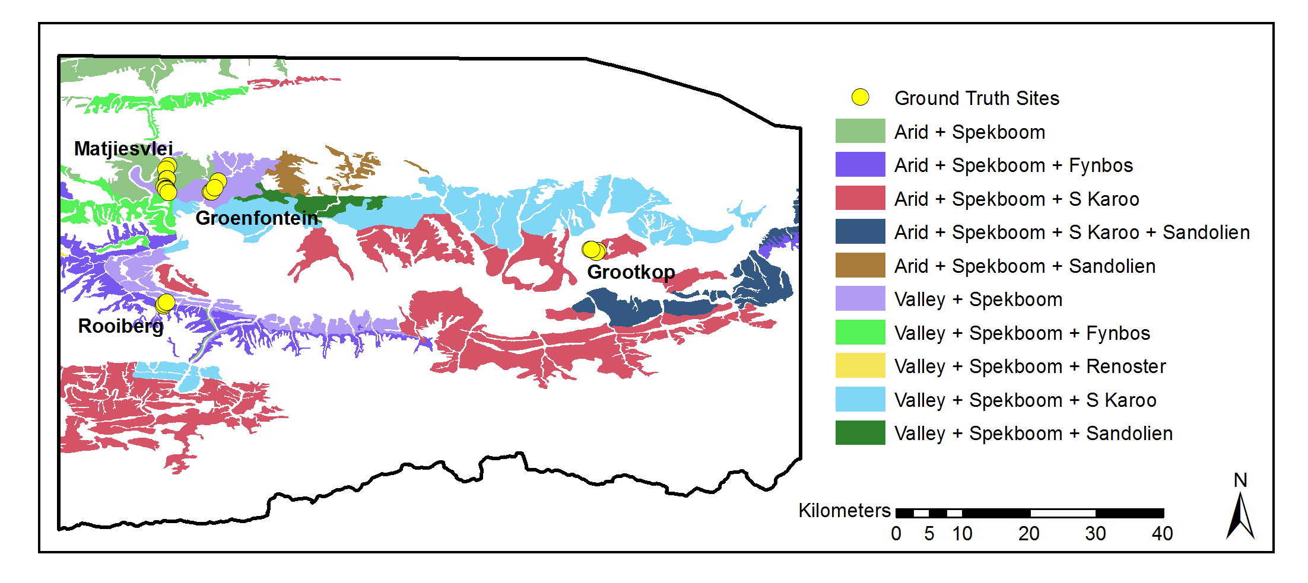

|  |  |
| --- | --- |
| Figure 2 Study area Spekboom habitats and field ground truth sites | Source: (Vlok, Cowling, and Wolf 2005) |

Table 1 In situ canopy cover data

|  |  |  |  |  |  |
| --- | --- | --- | --- | --- | --- |
| Area | Number | Geology | Mosaic | Degradation | Cover (%) |
| Matjiesvlei | 1a | Shale | Arid Spekboom | Intact | 6.0 |
|  | 1b |  |  | Intact | 22.5 |
|  | 2 |  |  | Intact | 70.0 |
|  | 3 |  |  | Intact | 85.0 |
|  | 4 |  |  | Intact | 65.0 |
|  | 5 |  |  | Intact | 37.5 |
|  | 6 |  |  | Intact | 17.5 |
|  | 7 |  |  | Intact | 15.0 |
|  | 8 |  |  | Intact | 2.0 |
| Groenfontein | 1 | Shale | Arid Spekboom | Severe | 0.0 |
|  | 2 |  |  | Severe | 4.0 |
|  | 3 |  |  | Severe | 10.0 |
|  | 4 |  |  | Moderate | 25.0 |
| Grootkop | 1 | Enon Conglomerate | Succulent Karoo | Intact | 22.5 |
|  | 2 |  |  | Severe | 0.5 |
|  | 3 |  |  | Moderate | 42.5 |
|  | 4 |  |  | Intact | 77.5 |
| Rooiberg | 1 | Sandstone | Fynbos | Intact | 20.0 |
|  | 2 |  |  | Moderate | 11.0 |
|  | 3 |  |  | Severe | 0.0 |

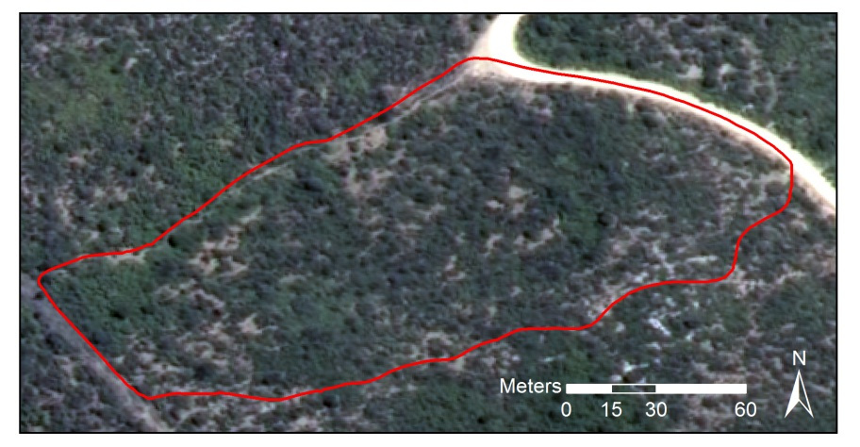

Figure 3 Matjiesvlei2 canopy cover ground truth site



For the second data set, a labelling scheme of three classes was adopted as described in Table 2. While canopy cover mapping is in essence a two-class problem (Spekboom and everything else), the addition of a third class, labelled as Tree, was beneficial. By merging multiple classes into a single class, the ability to adjust the priors of individual merged classes is lost. The class priors, or “weights”, control the relative emphasis the classifier places on identifying each class correctly (Mingguo, Qianguo, and Mingzhou 2009). The differentiation of Spekboom from trees is a particularly challenging part of the problem due to their spectral and textural similarity. Thus the addition of the Tree class is useful, as it allows control over the classification accuracy of trees relative to the other classes.

|  |  |
| --- | --- |
|  |  |
|  |  |
|  |  |
|  |  |

Due to the small 0.5m pixel size, limited DGPS and image spatial accuracy, dense vegetation growth and rugged terrain, it was not practical to obtain per-pixel class labels by in situ observation. Per-pixel class labels for the second data set were therefore obtained by visual discrimination and hand labelling of images. Image areas belonging to the various classes were delineated as polygons in a GIS package. An example is shown in Figure 4. All pixels within a polygon object were assigned the same class label. Polygon areas were selected to encompass variability in habitat and level of degradation. The total number of polygons and pixels labelled for each class is shown in Table 3. This data set is referred to as the “labelled pixel data” and was used for training and evaluating the classifier on a per-pixel basis.



**Class Label**

Figure 4 Example image class labels

Table 3 Details of labelled pixel data

|  |  |  |
| --- | --- | --- |
| Class Name | Polygons | Pixels |
| Spekboom | 52 | 27260 |
| Tree | 64 | 3357 |
| Background | 44 | 182044 |
| **Total** | **160** | **212661** |

## Features

A set of 46 features that would aid in describing the visual characteristics of Spekboom were evaluated. The set included a typical combination of spectral features, vegetation indices and texture features. Similar features have been used in Li et al. (2010) and Trias-Sanz, Stamon & Louchet (2008). The features can be grouped into two broad categories: per-pixel and sliding window features. The per-pixel features are found with the spectral information from only that pixel, while the sliding window features are found from some statistic or function of the pixels inside a small local neighbourhood. While the spectral resolution of the VHR imagery is poor, the spatial resolution allows description of vegetation structure and spatial patterns that is not possible with lower resolution satellite imagery. Texture is recognised as an important feature in biomass estimation in complex habitats (Singh, Malhi, and Bhagwat 2014; Lu 2006). The sliding window features were included to exploit this source of information in distinguishing the classes. A sliding window size of five was selected using a cross validated grid search, with the accuracy of a naïve Bayes classifier trained on the EntropyPc1 feature as the performance criterion. This size seems sensible as it is of the same order as the size of a small Spekboom clump.

Although the imagery was calibrated to surface reflectance, it was done at a coarse spatial scale and radiometric variations at a fine resolution were not taken into account. A normalised colour space was consequently included in the features to reduce intensity variations not removed by the surface reflectance corrections. The colour of an object is defined by the shape of its reflectance spectrum, while the intensity is defined by the spectral amplitude. The dimensions of the raw RGB colour space are coupled with intensity. Colour is captured by the relative amounts of the raw colour bands rather than their absolute values. Normalised colour features are defined by (Blauensteiner et al. 2006):

|  |  |  |  |  |
| --- | --- | --- | --- | --- |
| $$c_{i}^{n}=\frac{C_{i}}{\sum_{i=1}^{4}{C_{i}}}$$ |  |  |  | (1) |

Where $C_{i}$ are the raw R, G, B and NIR band values and $i$ is the band number. The denominator normalises for intensity.

Green, living vegetation absorbs light in the Photosynthetically Active Radiation (PAR) region of the spectrum, which corresponds to the red band. There is a sharp transition from absorption to reflection around 700nm (Gates 1980). Vegetation is highly reflective in the near infra-red band as the energy in these wavelengths is insufficient for photosynthesis and potentially harmful due to its heating effects. Various vegetation indices exploit these spectral properties. The Ratio Vegetation Index (RVI) is given by:

|  |  |  |
| --- | --- | --- |
| $$RVI=\frac{NIR}{R}$$ |  | (2) |

It has a range of zero to infinity and increases as the vegetation becomes denser and photosynthetically more active (Myneni et al. 1995). The well-known Normalised Difference Vegetation Index (NDVI) is defined as

|  |  |  |
| --- | --- | --- |
| $$NDVI=\frac{NIR-R}{NIR+R}$$ |  | (3) |

NDVI is limited to the range -1 to 1 and contains the same information as RVI, but is easier to visualise and interpret due to its limited range. Both indices are invariant to intensity changes.

The tasselled cap transform is a linear transform of the raw band feature space to a new orthogonal co-ordinate system, similar to a principal component transform. It was designed for agricultural wheat classification and was intended to reduce variability in soil and wheat classes by removing variation due to topography, sun angle and wheat growth stage (Kauth and Thomas 1976). The tasselled cap transform was approximated in this study using a principal component transform derived from the variance of the Spekboom class. The first component was aligned with Spekboom variation rather than wheat variation as in the original tasselled cap transform. As it is simply a rotation of the raw band space, its usefulness is as a dimensionality reduction technique similar to PCA, rather than as an extractor of novel features. The principal components of the normalised colours of Equation (1) were also included as features in the classification process.

Entropy is a statistic that describes the amount of randomness in a variable. It was included in our feature set as a texture feature to describe complexity in the local neighbourhood of a sliding window. The entropy of the values in the image window $x$ is defined by (Trias-Sanz, Stamon, and Louchet 2008):

|  |  |  |  |
| --- | --- | --- | --- |
| $$E(x)=-\sum_{i}{h_{i}(x)}\log_{2}{h_{i}(x)}$$ |  |  | (4) |

Where $h_{i}(x)$ is the probability in the $i^{th}$ histogram bin of $x$. A total of 256 bins were used in all cases.

In addition to the entropy, the median and the four central moment features (mean, standard deviation, skewness and kurtosis) of Li et al. (2010) were included as sliding window features. The first principal component, RVI, NDVI and normalised green channel were all used as inputs to the sliding window feature set. The complete feature set and their labels are listed in Table 4.

Table 4 Features

|  |  |  |
| --- | --- | --- |
| No. | Name | Description |
| 1 | R | Red |
| 2 | G | Green |
| 3 | B | Blue |
| 4 | NIR | Near-infrared |
| 5 | rN | Normalised R |
| 6 | gN | Normalised G |
| 7 | bN | Normalised B |
| 8 | nirN | Normalised NIR |
| 9 | NDVI | Normalised Difference Vegetation Index |
| 10 | RVI | Ratio Vegetation Index |
| 11-14 | tc1-4 | Tasselled cap components |
| 15-18 | pc1-4 | Principal components of raw bands |
| 19-22 | nc1-4 | Principal components of normalised bands |
| 23-26 | Entropy## | Sliding window entropy of pc1, RVI, NDVI and gN |
| 27-30 | Std## | Sliding window standard deviation of pc1, RVI, NDVI and gN |
| 31-34 | Mean## | Sliding window mean of pc1, RVI, NDVI and gN |
| 35-38 | Median## | Sliding window median of pc1, RVI, NDVI and gN |
| 39-42 | Skewness## | Sliding window skewness of pc1, RVI, NDVI and gN |
| 43-46 | Kurtosis## | Sliding window kurtosis of pc1, RVI, NDVI and gN |

## Feature Selection

The bands of the imagery have significant spectral overlap (Intergraph 2008) and consequently are highly correlated. Given that the bands are the source data for all the derived features, the derived feature definitions too contain some inter-dependencies. A number of authors have noted that feature redundancy can cause instability and sub-optimality in selected features when using traditional approaches such as ranking, forward selection and backward elimination (Sahu and Mishra 2011; Tolosi and Lengauer 2011; Strobl et al. 2008; Yousef et al. 2007). Redundancy can be reduced using a feature extraction approach such as PCA, but this requires computation of the full feature set, which is not practical in computationally demanding applications such as ours.

A feature ranking method, called feature clustering and ranking, was used to select relevant features in the presence of redundancy. The approach is described as follows:

1. Perform average-linkage hierarchical clustering (Szekely and Rizzo 2005) of the feature set using the correlation coefficient as the dissimilarity metric and create a dendrogram.
2. Select a natural number of clusters containing high correlation by visual inspection of the dendrogram.
3. Rank each cluster’s importance by finding the value of a relevance criterion for each individual feature and then finding the median of the feature relevance values in the cluster.
4. Select a single feature from each of the *N* clusters having the best importance scores.

More detail on the method can be found in Chapter 3. The number of clusters, *N*, was chosen using a grid search with the final classifier accuracy as performance measure. In this study, the accuracy of a naïve Bayes classifier was used as the feature relevance criterion. The naïve Bayes criterion makes no assumptions about the form of the class distributions and can thus provide a generic measure of separability. It is simple, fast and recognised as being accurate for a variety of problems (Hand and Yu 2001). To avoid biased accuracy estimates, all classifier accuracy evaluations, for feature relevance or selection of *N*, were done on unseen test data using a ten fold cross validation (Bishop 2003). Benefits of the cluster ranking method are its speed and that it allows hand-picking of the single features that represent each cluster. The flexibility to choose features allows the user to favour those features that are fastest to compute or perhaps to choose those features that are more readily understood.

## Classification and Canopy Cover Estimation

The decision tree, random forest, Support Vector Machine (SVM), Bayes normal and k-Nearest-Neighbour (kNN) classifiers were evaluated in this study. A decision tree is a tree of binary decision nodes based on thresholds of different features. Data is recursively split at each branch node until a terminal is reached representing a class label (Breiman et al. 1984). Training is performed by a greedy procedure, which iteratively adds nodes and selects features producing the best split for each node. Criteria used for choosing the best feature at each node include the information content, node purity and Fisher’s criterion (Jain, Duin, and Mao 2000). Overtraining is a concern and trees can be pruned in a post-training step to reduce variance. Decision tree execution is fast. They are known for their ease of interpretation and node decisions can help provide insight into the problem. Decisions are usually binary and based on a single feature. As a result, the decision boundary is comprised of stepwise sections parallel to the feature axes and is at best an approximation to the optimal boundary (Jain, Duin, and Mao 2000). Decision trees are flexible and broadly applied as they make no assumptions on the form of class distributions and can deal with categorical as well as continuous variables (Breiman et al. 1984).

Random forests are classifiers that use bootstrapped aggregation (bagging) (Breiman 1996) of a large collection of decision tree classifiers. Each tree is trained on a bootstrapped version of the data set and the decision feature for each node is selected from a random subset of the full feature set (Breiman 2001). The bootstrapping and random feature subsets help introduce variation amongst the base tree classifiers. The combination of uncorrelated decision trees has greater predictive power than any single one. Importantly, a random forest is not prone to overtraining. Random forests are also robust to mislabelled training data. Both training and execution are moderately demanding of computation time. The two main parameters for tuning a random forest are the number of trees and the number of features considered for each node.

The Support Vector Machine (SVM) has been something of a breakthrough in pattern recognition and has received widespread successful use in recent years (Amorós López et al. 2011; Sahu and Mishra 2011; Li et al. 2010; Yousef et al. 2007). The SVM was first posed as the problem of maximising the margin from a two-class linear decision boundary to the nearest objects, called “support vectors” (Burges 1998). The decision boundary is determined only by the support vectors, not directly by features or generative descriptions of class distributions. The SVM minimises the Vapnik-Chervonenkis (VC) dimension, a measure of the complexity of the classifier. This is an important property of the SVM and explains how it effectively adapts its complexity to the data, is robust to overtraining and performs well in high dimensional feature spaces. The original formulation was extended to the case of overlapping multi-class problems using a penalty term with user-defined multiplier *C*, that punishes class overlap. Using the kernel trick, the linear SVM was further extended to allow modelling of non-linear decision boundaries (Burges 1998). Different kernels such as polynomials or Radial Basis Functions (RBF) may be chosen to suit the given problem. In our evaluation, an RBF kernel was used for the SVM classifier. The training procedure is a quadratic optimisation problem which is computationally demanding. Execution is fast however as it only requires evaluation of the kernel function for the support vector – object vector pairs (Jain, Duin, and Mao 2000).

The Bayes normal classifier, sometimes referred to as the maximum likelihood (ML) classifier, assumes the classes are normally distributed. Mean and covariance parameters are estimated for each class from the data, usually with the maximum likelihood criterion. Bayes rule is then used to define the decision boundary (Duin and Tax 2005).

The kNN classifier labels test objects by finding the mode of classes of the closest k training objects (Bishop 2003). Any distance metric can be used for finding neighbours, but the Euclidean distance measure is prevalent and was used in our study. This classifier is a useful benchmark as it almost always performs reasonably well, requires only one parameter and makes no assumptions about class distributions (Jain, Duin, and Mao 2000). It requires finding distances to the full training set, which can slow execution for large datasets.

User supplied tuning parameters for the classifiers were found with cross-validated grid searches. (OpenCV Development Team 2014)

Morphological operators (Serra and Soille 1994) were applied as a post processing step to the classifier produced maps to remove noise and smooth boundaries. Assuming that the majority of Spekboom plants were big enough to cover more than one pixel, a morphological opening was applied to remove isolated Spekboom pixels. Following this, spurious wrinkles and holes in the Spekboom boundaries were removed with a morphological closing operation. The assumption here being that Spekboom typically grows in solid clumps and any real gaps in these clumps would be more than a pixel wide. These operations can be seen as a way of further incorporating spatial context into the classification.

|  |  |
| --- | --- |
|  |  |
|  |  |
|  |  |
|  |  |
|  |  |
|  |  |

## Validation

The per-pixel performance of the candidate classifiers was evaluated on the selected features using the labelled pixel data. To avoid biased estimates of performance, ten fold cross validation was used for classifier evaluation. The canopy cover performance of the classifiers was tested on the in situ canopy cover data. After applying the classifiers and morphological operations to the relevant images, canopy cover estimates were extracted by evaluating the fractional portion of Spekboom inside the areas of the field site polygons. These estimates were compared to the in situ canopy cover data.

# Results

## Feature Selection

The dendrogram showing the clustering of our feature set, is plotted in Figure 5. The line in red shows the correlation threshold value at which the feature clusters were extracted. This value was selected as a relatively stable point in the hierarchy and one where the correlation amongst features is strong.



Figure 5 Clustering of correlated features

Table 5 lists the clusters ordered by their importance, along with their component features.

Table 5 Ranked clusters

|  |  |  |
| --- | --- | --- |
| Rank. | Importance (%) | Features |
| 1 | 68.27 | rN, nirN, NDVI, RVI, tc2, pc2, nc1, MeanRVI, MedianRVI, MeanNDVI, MedianNDVI |
| 2 | 61.38 | R, G, B, NIR, tc1, pc1, MeanPc1, MedianPc1 |
| 3 | 60.41 | EntropyPc1 |
| 4 | 55.23 | gN, MeanGn, MedianGn |
| 5 | 54.52 | bN |
| 6 | 53.57 | nc2, nc4 |
| 7 | 50.57 | tc4, nc3 |
| 8 | 49.34 | pc4 |
| 9 | 47.93 | EntropyRVI, StdRVI, EntropyNDVI, StdNDVI |
| 10 | 43.96 | StdPc1 |
| 11 | 43.62 | EntropyGn, StdGn |
| 12 | 42.65 | tc3, pc3 |
| 13 | 41.29 | SkewnessRVI, SkewnessNDVI |
| 14 | 64.73 | SkewnessGn |
| 15 | 64.81 | KurtosisRVI, KurtosisNDVI |
| 16 | 64.97 | SkewnessPc1 |
| 17 | 65.14 | KurtosisGn |
| 18 | 66.14 | KurtosisPc1 |

The NDVI, pc1, EntropyPc1, gN, bN and nc2 features were selected from the top six clusters.

## Classification and Canopy Cover Estimation

Table 7 compares the performance of the candidate classifiers. The table results are sorted according to the Mean Absolute canopy cover Error (MAE) in the last column. Of the performance measures in the table, this is the only one evaluated against the in situ canopy cover data, the rest were evaluated against the labelled pixel data. Three- and two-class errors are reported as the class prior weighted errors i.e. the mean of the errors of omission. Cohen’s Kappa and consumer’s and producer’s accuracies are given for the two-class case.

|  |  |
| --- | --- |
|  |  |
|  |  |
|  |  |
|  |  |
|  |  |
|  |  |

Table 7 Classifier performance comparison

|  |  |  |  |  |  |  |
| --- | --- | --- | --- | --- | --- | --- |
| Classifier | 3 Class Error (%) | 2 Class Error (%) | CA (Bg / Sb)a | PA (Bg / Sb)a | Kappa | MAE (SAE)a |
| Decision Tree | 9.46 | 3.57 | 95.28 / 98.04 | 98.32 / 94.53 | 0.93 | 5.85 (4.65) |
| Random Forest | 9.16 | 2.62 | 97.31 / 97.51 | 97.80 / 96.96 | 0.95 | 7.09 (6.07) |
| kNN | 10.45 | 1.72 | 98.94 / 97.49 | 97.74 / 98.82 | 0.96 | 7.60 (6.20) |
| SVM | 10.58 | 2.81 | 98.79 / 95.33 | 95.70 / 98.69 | 0.94 | 7.99 (8.33) |
| Bayes Normal | 16.23 | 8.97 | 86.97 / 98.23 | 98.66 / 83.40 | 0.83 | 8.08 (8.35) |

a CA = Consumer’s Accuracy (%), PA = Producer’s Accuracy (%), Bg = Background, Sb = Spekboom , MAE = Mean Absolute canopy cover error on in situ canopy cover data (%), SAE = Standard deviation of Absolute canopy cover errors on in situ canopy cover data (%)

The decision tree three-class and two-class confusion matrices and performances, obtained from the labelled pixel data, are given in Table 8 and Table 9 respectively. The three-class confusion matrix shows that the Tree class overlaps with both the Spekboom and Background classes, but that the overlap is larger with the Background class. Table 10 shows the canopy cover estimates obtained from the post-processed decision tree output for each of the in situ canopy cover sites. The mean of the absolute canopy cover error is 5.85% with a standard deviation of 4.65%.

Table 8 Decision tree three-class confusion matrix

|  |  |  |  |  |  |
| --- | --- | --- | --- | --- | --- |
|  | Background | Spekboom | Tree | Total | PA (%)a |
| **Background** | 24773 | 317 | 2170 | 27260 | 90.88 |
| **Spekboom** | 323 | 25769 | 1168 | 27260 | 94.53 |
| **Tree** | 271 | 197 | 2889 | 3357 | 86.06 |
| **Total** | 25367 | 26283 | 6227 | 57877 |  |
| **CA (%)a** | 97.66 | 98.04 | 46.39 |  |  |
| **Kappa** | 0.87 |  |  |  |  |
| **Overall Error (%)** | 9.51 |  |  |  |  |

a CA = Consumer’s accuracy, PA = Producer’s accuracy

Table 9 Decision tree two-class confusion matrix

|  |  |  |  |  |
| --- | --- | --- | --- | --- |
|  | Background | Spekboom | Total | PA (%)a |
| **Background** | 30103 | 514 | 30617 | 98.32 |
| **Spekboom** | 1491 | 25769 | 27260 | 94.53 |
| **Total** | 31594 | 26283 | 57877 |  |
| **CA (%)a** | 95.28 | 98.04 |  |  |
| **Kappa** | 0.93 |  |  |  |
| **Overall Error (%)** | 3.57 |  |  |  |

a CA = Consumer’s accuracy, PA = Producer’s accuracy

Table 10 Decision Tree field canopy cover estimates

|  |  |  |  |
| --- | --- | --- | --- |
| Area | Num. | Ground Truth (%) | Classifier (%) |
| Groenfontein | 1 | 0.00 | 0.07 |
|  | 2 | 4.00 | 0.47 |
|  | 3 | 10.00 | 8.21 |
|  | 4 | 25.00 | 17.44 |
| Matjiesvlei | 1a | 6.00 | 7.21 |
|  | 1b | 22.50 | 31.37 |
|  | 2 | 70.00 | 67.38 |
|  | 3 | 85.00 | 73.12 |
|  | 4 | 65.00 | 70.34 |
|  | 5 | 37.50 | 35.95 |
|  | 6 | 17.50 | 12.01 |
|  | 7 | 15.00 | 25.74 |
|  | 8 | 2.00 | 5.42 |
| Rooiberg | 1 | 20.00 | 6.03 |
|  | 2 | 11.00 | 1.03 |
|  | 3 | 0.00 | 0.00 |
| Grootkop | 1 | 22.50 | 8.05 |
|  | 2 | 0.50 | 0.22 |
|  | 3 | 42.50 | 34.38 |
|  | 4 | 77.50 | 71.27 |
| **MAE (SAE)a** | | | **5.85% (4.65%)** |

aMAE = Mean of absolute canopy cover errors (%), SAE = Standard deviation of absolute canopy cover errors (%)

The decision tree classifier was applied to the study area image mosaic to produce a Spekboom canopy cover map which was morphologically post-processed. Figure 6 to Figure 9 show close-up examples of the resulting canopy cover map for each of the canopy cover ground truth areas (as described in Table 1). Some spatial variation is noticeable, as suggested by the SAE of Table 10. Arid areas seem more prone to underestimation, possibly due to spectral mixing occurring with bare ground around the canopy borders and also due to the smaller and less dense stands occurring in these areas. Conversely, there seems to be a slight overestimation in more densely vegetated areas. Confusion due to spectral mixing with other green vegetation seems the likely cause. In general however, the canopy cover map appears accurate over the study area.

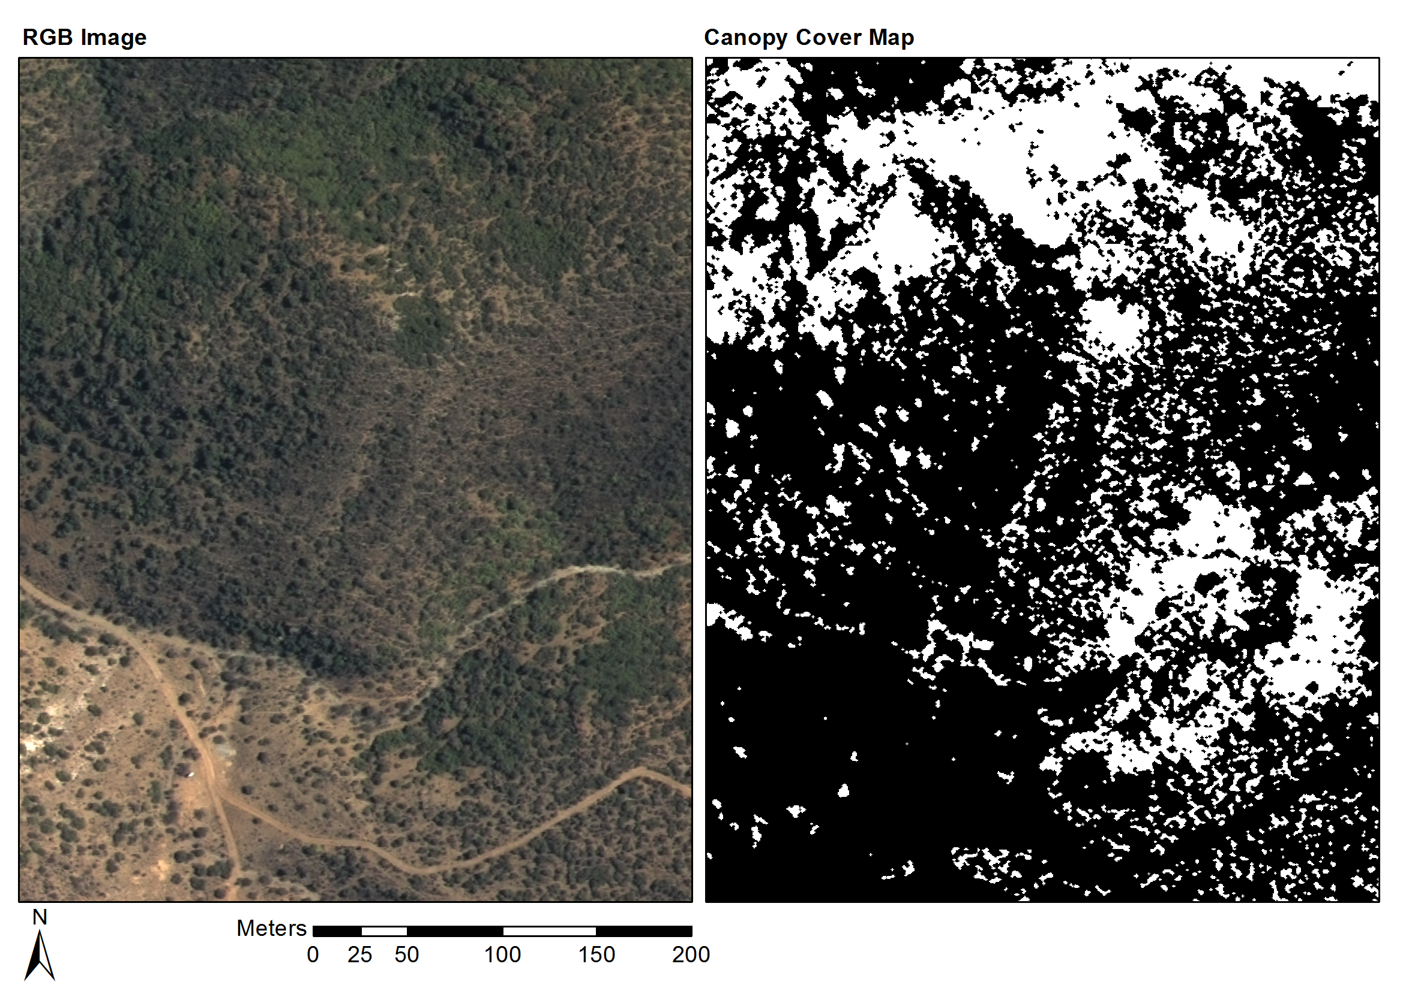

Figure 6 Groenfontein classification (Habitat: valley thicket with Spekboom)

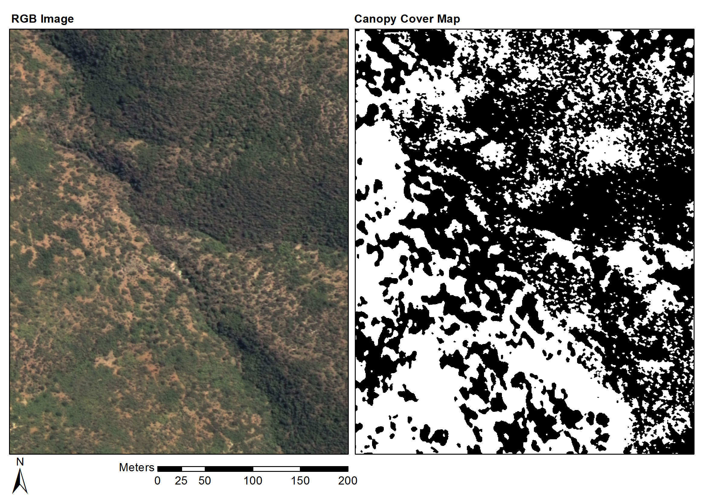

Figure 7 Matjiesvlei classification (Habitat: arid thicket with Spekboom)

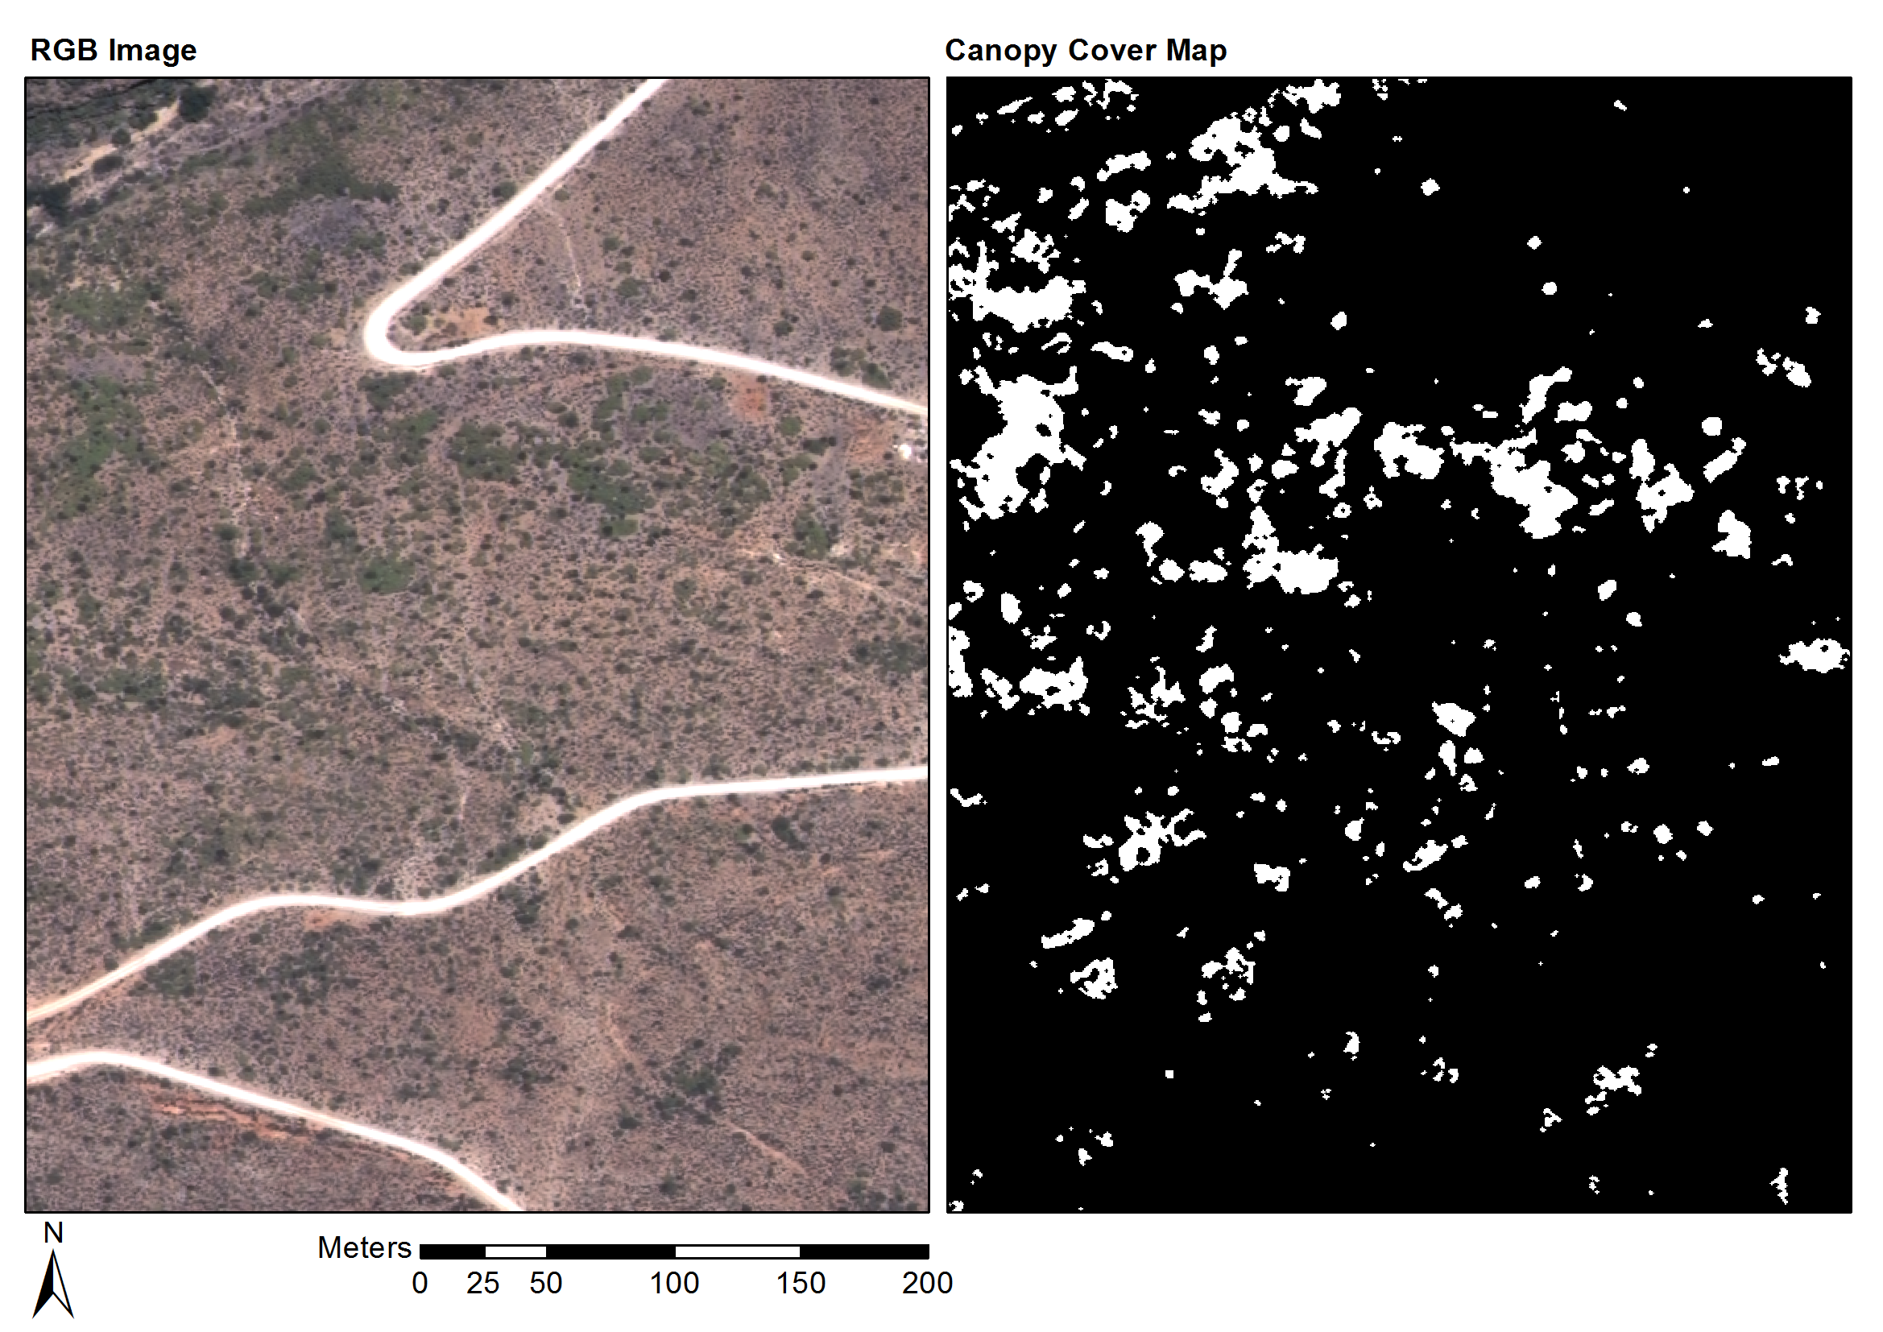

Figure 8 Rooiberg classification (Habitat: arid thicket with Spekboom and Fynbos mosaic)

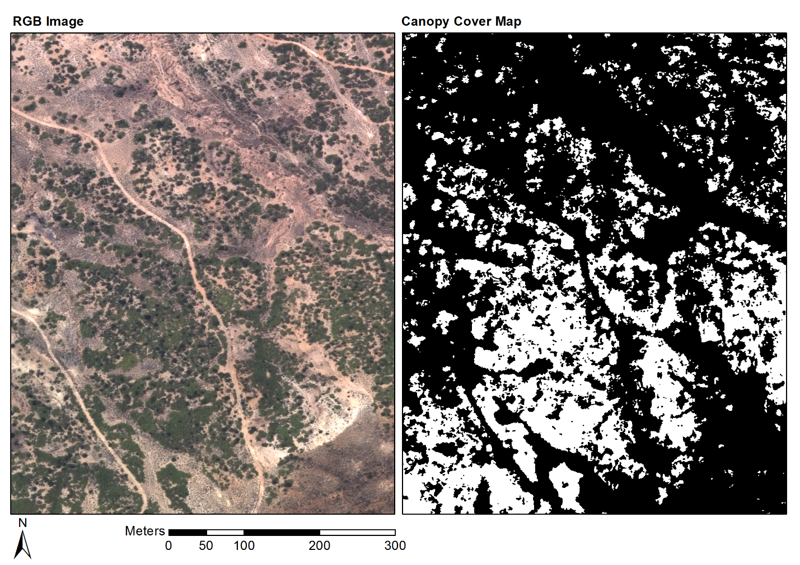

Figure 9 Grootkop classification (Habitat: arid thicket with Spekboom and Succulent Karoo mosaic)

# Discussion

## Feature Selection

Table 5 reveals a number of interesting properties of the features. Firstly, it is clear that there is significant redundancy amongst the features. The correlation between the R, G, B and NIR bands is strong (>0.7), likely due to strong coupling with intensity. The bands are consequently all grouped into a single cluster. While the definitions of the nirN, NDVI and RVI features are quite different, they are all describing the same spectral property of vegetation, namely high absorption in the red band and high reflectance in the NIR band. This is confirmed by their collection in the same cluster.

EntropyPc1 is ranked highly (third) in its own cluster, which supports the hypothesis that texture is an important property for mapping vegetation in VHR imagery. It is, however, the only texture feature in the best eight clusters. Measures of vegetation texture are sensitive to shadow variations, which are unavoidable in aerial imagery due to the long flight times and varying sun angle. At the 0.5m image resolution, texture will be descriptive of bush clumps more than individual Spekboom plants. The bush clumps vary significantly in their composition and character with habitat and level of degradation. We believe the paucity of texture features in informative clusters is likely due to the bush clump and shadow variations.

The importance of bN is unexpected. The blue channel is particularly susceptible to haze effects and intuitively should not hold much discriminating power for vegetation. Inspecting bN images shows an inversion of the topography shading seen in other channels. Sunlit northern slopes are dimmer and shaded southern slopes brighter. This occurs because in the shaded areas, the blue light, which scatters more readily, is the dominant band of illumination. The contribution of bN is not understood fully but we believe its value lies in this property and that it helps distinguish shaded vegetation from genuinely dark vegetation. In their tree mapping study, Key et al. (2001) also found the blue band to be valuable due to its insensitivity to shadowing issues.

The gN feature, its mean and its median form their own cluster. The mean sliding window feature, median sliding window feature and source feature operated on by those sliding windows are strongly correlated with each other as is expected.

The NDVI, pc1, EntropyPc1, gN, bN and nc2 features were selected from the top six clusters.

## Classification and Canopy Cover Estimation

With the exception of the Bayes Normal classifier, the classifiers’ performance was remarkably good. The performances of the kNN and decision tree classifiers are as good as or better than the more complex SVM and random forest classifiers (see Table 7). The excellent performance of a diverse group of classifiers suggests that an informative feature set was selected. The notably poorer performance of the Bayes Normal classifier implies the classes are not normally distributed. The three-class errors are larger than the two-class errors due the Tree class overlapping substantially with the Background class. Errors due to Tree samples being assigned to the Background class, and vice versa, are negated when the tree class is lumped into the Background class.

It is apparent that for each classifier, the per-pixel two-class error and canopy cover MAE, are poorly correlated. This is likely due to the nature of the two ground truth data sets. As classes were not always obvious from visual inspection of the images, labelled pixels in the image ground truth were restricted to areas where there was a reasonable confidence in the label accuracy. This will have limited the image ground truth representivity of real class distributions and likely biased the image ground truth to be more separable compared to actual field data. The field ground truth was made from a visual inspection on site which is approximate and subject to human error. The bias of the image ground truth performance and inaccuracies in the field ground truth likely explain the observed difference between image and field ground truth performances. The post classification morphological operations were found to improve accuracy on the field ground truth.

An inspection of the images of the field sites suggested that the Rooiberg ground truth estimates were somewhat inflated, likely due to human error. Overlaying the classifier output maps on the imagery indicated that the classifier was also underestimating the actual canopy extent. As a result of the sandstone/quartzite geology of the area, the Spekboom plants at Rooiberg are smaller and have a canopy that is less dense than those in other sites. We believe this helps explain the canopy cover underestimation in this area.

(Ghosh and Joshi 2014; Heumann 2011; Baraldi et al. 2010; Johansen et al. 2007; Mehner et al. 2004)

# Conclusions

Accurate Spekboom canopy cover estimates were obtained across the study area using a per-pixel classification approach. Homogenisation to surface reflectance by calibration with satellite data provided radiometric consistency and allowed application of a single classification algorithm over an extended area. Six features, consisting of a combination of spectral, textural and vegetation index type measures, were selected using a feature clustering and ranking method. Out of a set of candidate classifiers, a decision tree produced the best canopy cover accuracy, and was subsequently used to produce a map of the study area. A mean absolute canopy cover error of 5.86% over 20 ground truth sites was achieved.

While some variation in the canopy cover accuracy was observed over different habitats, the classifier performance was consistent over the study area in general. . This study is one of few examples of vegetation mapping using VHR imagery over a large area (Eisfelder, Kuenzer, and Dech 2012; Lu 2006). By incorporating ground truth from new areas, the techniques used to produce this map could be applied to the rest of the thicket biome.The availability of a Spekboom canopy cover mapping technique will be a valuable starting point for developing measures of other environmental variables such as biomass and biodiversity (Eisfelder, Kuenzer, and Dech 2012; Suganuma et al. 2006; Ludwig, Reynolds, and Whitson 1975).

# Acknowledgement

We would like to thank Adrian Roos and Intergraph South Africa for providing a license for Intergraph PPS, Bernard Jacobs of Geospace International for assistance in understanding the NGI image processing workflow and in obtaining DMC relative spectral response data, Theo Pauw and Garth Stephenson of CGA for assistance with computing and software resources and Julie Verhulp and NGI for provision of the aerial imagery. The financial assistance of the National Research Foundation (NRF) towards this research is hereby acknowledged. Opinions expressed and conclusions arrived at, are those of the author and are not necessarily to be attributed to the NRF. Lastly, we are grateful for funding from the Gamtoos Irrigation Board (GIB). GIB was otherwise not involved in this research.

REFERENCES

Adie, H., and R.I. Yeaton. 2013. “Regeneration Dynamics in Arid Subtropical Thicket, South Africa.” *South African Journal of Botany* 88 (September). South African Association of Botanists: 80–85. doi:10.1016/j.sajb.2013.05.010.

Amorós López, J., E. Izquierdo Verdiguier, L. Gómez Chova, J. Muñoz Marí, J.Z. Rodríguez Barreiro, G. Camps Valls, and J. Calpe Maravilla. 2011. “Land Cover Classification of VHR Airborne Images for Citrus Grove Identification.” *ISPRS Journal of Photogrammetry and Remote Sensing* 66 (1). Elsevier B.V.: 115–123. doi:10.1016/j.isprsjprs.2010.09.008.

Baraldi, Andrea, Laurent Durieux, Dario Simonetti, Giulia Conchedda, Francesco Holecz, and Palma Blonda. 2010. “Automatic Spectral-Rule-Based Preliminary Classification of Radiometrically Calibrated SPOT-4/-5/IRS, AVHRR/MSG, AATSR, IKONOS/QuickBird/OrbView/GeoEye, and DMC/SPOT-1/-2 imagery—Part I: System Design and Implementation.” *IEEE Transactions on Geoscience and Remote Sensing* 48 (3): 1299–1325.

Basu, Saikat, Sangram Ganguly, Ramakrishna R. Nemani, Supratik Mukhopadhyay, Gong Zhang, Cristina Milesi, Andrew Michaelis, et al. 2015. “A Semiautomated Probabilistic Framework for Tree-Cover Delineation From 1-M NAIP Imagery Using a High-Performance Computing Architecture.” *IEEE Transactions on Geoscience and Remote Sensing* 53 (10): 5690–5708. doi:10.1109/TGRS.2015.2428197.

Bishop, Christopher M. 2003. *Neural Networks for Pattern Recognition*. New York: Oxford University Press. doi:10.1002/0470854774.

Blauensteiner, Philipp, Horst Wildenauer, Allan Hanbury, and Martin Kampel. 2006. “On Colour Spaces for Change Detection and Shadow Suppression.” In *Computer Vision Winter Workshop 2006*, edited by Ondrej Chum and Vojtech Franc, 1–6. Telc, Czech Republic: Czech Pattern Recognition Society.

Boyden, J, D Walden, R Bartolo, P Bayliss, Supervising Scientist Division, and Northern Territory. 2007. “Utility of VHR Remote Sensing Data for Landscape Scale Assessment of the Environmental Weed Para Grass [UROCHLOA MUTICA, (FORSSK), NGUYEN] on a Tropical Floodplain.” In *28th Asian Conference on Remote Sensing 2007, ACRS 2007*, 1:551–556.

Bradski, G. 2000. “The OpenCV Library.” *Dr. Dobb’s Journal of Software Tools* 25 (120): 122–125.

Breiman, Leo. 1996. “Bagging Predictors.” *Machine Learning* 24 (2): 123–140.

Breiman, Leo. 2001. “Random Forests.” *Machine Learning* 45 (1): 5–32. doi:10.1023/A:1010933404324.

Breiman, Leo, J. Friedman, R. Olshen, and C. Stone. 1984. *Classification and Regression Trees*. Calif.: Wadsworth.

Burges, Christopher J.C. 1998. “A Tutorial on Support Vector Machines for Pattern Recognition.” *Data Mining and Knowledge Discovery* 2 (2): 121–167. doi:10.1023/A:1009715923555.

Curran, Patrick, David Smedley, Peter Thompson, and Andrew T. Knight. 2012. “Mapping Restoration Opportunity for Collaborating with Land Managers in a Carbon Credit-Funded Restoration Program in the Makana Municipality, Eastern Cape, South Africa.” *Restoration Ecology* 20 (1): 56–64. doi:10.1111/j.1526-100X.2010.00746.x.

de Castro, Ana Isabel, Montserrat Jurado-Expósito, J. M. Peña-Barragán, and Francisca López-Granados. 2012. “Airborne Multi-Spectral Imagery for Mapping Cruciferous Weeds in Cereal and Legume Crops.” *Precision Agriculture* 13 (3): 302–321. doi:10.1007/s11119-011-9247-0.

Duin, R P W, and David M. J. Tax. 2005. “Statistical Pattern Recognition.” In *Handbook of Pattern Recognition and Computer Vision, 3rd Ed.*, edited by CH Chen and PSP Wang, 1–21. Singapore: World Scientific. doi:10.1142/9789812775320_0001.

Eisfelder, Christina, Claudia Kuenzer, and Stefan Dech. 2012. “Derivation of Biomass Information for Semi-Arid Areas Using Remote-Sensing Data.” *International Journal of Remote Sensing* 33 (9): 2937–2984.

Gates, David M. 1980. *Biophysical Ecology*. Springer Advanced Texts in Life Sciences. New York: Springer. doi:10.1007/978-1-4612-6024-0.

GDAL Development Team. 2014. “Geospatial Data Abstraction Library.” *Open Source Geospatial Foundation*. http://www.gdal.org/.

Ghosh, Aniruddha, and P.K. Joshi. 2014. “A Comparison of Selected Classification Algorithms for Mapping Bamboo Patches in Lower Gangetic Plains Using Very High Resolution WorldView 2 Imagery.” *International Journal of Applied Earth Observation and Geoinformation* 26 (February). Elsevier B.V.: 298–311. doi:10.1016/j.jag.2013.08.011.

Hand, David J, and Kerning Yu. 2001. “Idiot’s Bayes - Not So Stupid After All?” *International Statisitical Review* 69 (3): 385–398.

Heumann, B. W. 2011. “Satellite Remote Sensing of Mangrove Forests: Recent Advances and Future Opportunities.” *Progress in Physical Geography* 35 (1): 87–108. doi:10.1177/0309133310385371.

Intergraph. 2008. “Digital Mapping Camera System.” Huntsville, USA: Intergraph. http://www.geospace.co.za/pdf/DMC Brochure.pdf.

Jain, Anil K, Robert P W Duin, and Jianchang Mao. 2000. “Statistical Pattern Recognition: A Review.” *IEEE Transactions on Pattern Analysis and Machine Intelligence* 22 (1): 4–37.

Johansen, Kasper, Nicholas C. Coops, Sarah E. Gergel, and Yulia Stange. 2007. “Application of High Spatial Resolution Satellite Imagery for Riparian and Forest Ecosystem Classification.” *Remote Sensing of Environment* 110 (1): 29–44. doi:10.1016/j.rse.2007.02.014.

Kauth, R. J., and G. S. Thomas. 1976. “The Tasselled Cap -- a Graphic Description of the Spectral-Temporal Development of Agricultural Crops as Seen by LANDSAT.” In *Symposium on Machine Processing of Remotely Sensed Data*, 4B41-4B51. Purdue University of West Lafayette, Indiana, USA: IEEE.

Key, Thomas, T.A. Warner, J.B. McGraw, and M.A. Fajvan. 2001. “A Comparison of Multispectral and Multitemporal Information in High Spatial Resolution Imagery for Classification of Individual Tree Species in a Temperate Hardwood Forest.” *Remote Sensing of Environment* 75 (1). Elsevier: 100–112.

Kollár, Szilvia, Zoltán Vekerdy, and Béla Márkus. 2013. “Aerial Image Classification for the Mapping of Riparian Vegetation Habitats.” *Acta Silvatica et Lignaria Hungarica* 9 (1): 119–133. doi:10.2478/aslh-2013-0010.

Li, Zhengrong, Ross F. Hayward, Jinglan Zhang, Hang Jin, and Rodney A Walker. 2010. “Evaluation of Spectral and Texture Features for Object-Based Vegetation Species Classification Using Support Vector Machines.” In *ISPRS TC VII Symposium – 100 Years ISPRS*, edited by W Wagner and B Székely, XXXVIII:122–127. Vienna, Austria: IAPRS.

Lu, Dengsheng. 2006. “The Potential and Challenge of Remote Sensing Based Biomass Estimation.” *International Journal of Remote Sensing* 27 (7): 1297–1328. doi:10.1080/01431160500486732.

Ludwig, John A, James F Reynolds, and Paul D Whitson. 1975. “Size-Biomass Relationships of Several Chihuahuan Desert Shrubs.” *American Midland Naturalist* 94 (2): 451–461.

Marais, C, Richard M. Cowling, and M Powell. 2009. “Establishing the Platform for a Carbon Sequestration Market in South Africa: The Working for Woodlands Subtropical Thicket Restoration Programme.” In *XIII World Forestry Congress*, 1–13. Buenos Aires, Argentina.

Mehner, Henny, Mark Cutler, David Fairbairn, and Gillian Thompson. 2004. “Remote Sensing of Upland Vegetation: The Potential of High Spatial Resolution Satellite Sensors.” *Global Ecology and Biogeography* 13 (4): 359–369. doi:10.1111/j.1466-822X.2004.00096.x.

Mills, Anthony J., JN Blignaut, Richard M. Cowling, A Knipe, C Marais, S Marais, SM Pierce, M Powell, AM Sigwela, and A Skowno. 2010. *Investing in Sustainability. Restoring Degraded Thicket, Creating Jobs, Capturing Carbon and Earning Green Credit.* *Published by Climate Action Partnership, Cape Town, and Wilderness Foundation, Port Elizabeth*. Series. Climate Action Partnership, Cape Town and Wilderness Foundation, Port Elizabeth.

Mills, Anthony J., and Richard M. Cowling. 2006. “Rate of Carbon Sequestration at Two Thicket Restoration Sites in the Eastern Cape, South Africa.” *Restoration Ecology* 14 (1): 38–49.

Mills, Anthony J., and Richard M. Cowling. 2010. “Below-Ground Carbon Stocks in Intact and Transformed Subtropical Thicket Landscapes in Semi-Arid South Africa.” *Journal of Arid Environments* 74 (1). Elsevier Ltd: 93–100. doi:10.1016/j.jaridenv.2009.07.002.

Mills, Anthony J., Richard M. Cowling, MV Fey, GIH Kerley, JS Donaldson, AM Sigwela, A Skowno, and P Rundel. 2005. “Effects of Goat Pastoralism on Ecosystem Carbon Storage in Semiarid Thicket, Eastern Cape, South Africa.” *Austral Ecology* 30: 797–804.

Mills, Anthony J., Jane K Turpie, Richard M. Cowling, C Marais, GIH Kerley, G Richard, AM Sigwela, and M Powell. 2007. “Assessing Costs, Benefits, and Feasibility of Restoring Natural Capital in Subtropical Thicket in South Africa.” In *Restoring Natural Capital: Science, Business and Practice (The Science and Practice of Ecological Restoration Series)*, edited by J Aronson, S Milton, and J Blignaut, 2:179–187. Washington DC: Island Press.

Mingguo, Zheng, Cai Qianguo, and Qin Mingzhou. 2009. “The Effect of Prior Probabilities in the Maximum Likelihood Classification on Individual Classes.” *Photogrammetric Engineering & Remote Sensing*, IGARSS 2005 held 25-29 July, 75 (9). Seoul, South Korea: IEEE: 1109–1117. doi:10.14358/PERS.75.9.1109.

Mustafa, Yaseen T, and Hindav N Habeeb. 2014. “Object Based Technique for Delineating and Mapping 15 Tree Species Using VHR WorldView-2 Imagery.” In *Proc. SPIE*, 9239:92390G–92390G–13. doi:10.1117/12.2067280.

Myneni, R.B., F.G. Hall, P.J. Sellers, and A.L. Marshak. 1995. “The Interpretation of Spectral Vegetation Indexes.” *IEEE Transactions on Geoscience and Remote Sensing* 33 (2): 481–486. doi:10.1109/36.377948.

OpenCV Development Team. 2014. “OpenCV Documentation.” *Open Source Computer Vision Library*. http://docs.opencv.org/.

Ouyang, Zu-Tao, Mo-Qian Zhang, Xiao Xie, Qi Shen, Hai-Qiang Guo, and Bin Zhao. 2011. “A Comparison of Pixel-Based and Object-Oriented Approaches to VHR Imagery for Mapping Saltmarsh Plants.” *Ecological Informatics* 6 (2). Elsevier B.V.: 136–146. doi:10.1016/j.ecoinf.2011.01.002.

Powell, Michael John. 2009. *Restoration of Degraded Subtropical Thickets in the Baviaanskloof Megareserve, South Africa*. MSc. thesis. Series. Master’s thesis. Grahamstown: Rhodes University, Department of Environmental Science.

Sahu, Barnali, and Debahuti Mishra. 2011. “A Novel Approach for Selecting Informative Genes from Gene Expression Data Using Signal-to-Noise Ratio and T-Statistics.” In *2011 2nd International Conference on Computer and Communication Technology (ICCCT-2011)*, 5–10. Allahabad, India: IEEE. doi:10.1109/ICCCT.2011.6075207.

Serra, Jean, and Pierre Soille, eds. 1994. “Mathematical Morphology and Its Applications to Image Processing.” In *2nd International Symposium on Mathematical Morphology (ISMM’94)*, 383. Computational Imaging and Vision. Kluwer Academic Publishers.

Sigwela, AM, GIH Kerley, Anthony J. Mills, and Richard M. Cowling. 2009. “The Impact of Browsing-Induced Degradation on the Reproduction of Subtropical Thicket Canopy Shrubs and Trees.” *South African Journal of Botany* 75 (2). Elsevier B.V.: 262–267. doi:10.1016/j.sajb.2008.12.001.

Singh, Minerva, Yadvinder Malhi, and Shonil Bhagwat. 2014. “Biomass Estimation of Mixed Forest Landscape Using a Fourier Transform Texture-Based Approach on Very-High-Resolution Optical Satellite Imagery.” *International Journal of Remote Sensing* 35 (9): 3331–3349. doi:10.1080/01431161.2014.903441.

Strobl, Carolin, Anne-Laure Boulesteix, Thomas Kneib, Thomas Augustin, and Achim Zeileis. 2008. “Conditional Variable Importance for Random Forests.” *BMC Bioinformatics* 9 (January): 307. doi:10.1186/1471-2105-9-307.

Suganuma, Hideki, Yukuo Abe, Masahiko Taniguchi, Hiroyuki Tanouchi, Hajime Utsugi, Toshinori Kojima, and Koichi Yamada. 2006. “Stand Biomass Estimation Method by Canopy Coverage for Application to Remote Sensing in an Arid Area of Western Australia.” *Forest Ecology and Management* 222 (1–3): 75–87. doi:10.1016/j.foreco.2005.10.014.

Szekely, Gabor J., and Maria L. Rizzo. 2005. “Hierarchical Clustering via Joint between-within Distances: Extending Ward’s Minimum Variance Method.” *Journal of Classification* 22 (2): 151–183. doi:10.1007/s00357-005-0012-9.

Thompson, Mark, Jan Vlok, Mathieu Rouget, M T Hoffman, and Richard M. Cowling. 2009. “Mapping Grazing-Induced Degradation in a Semi-Arid Environment: A Rapid and Cost Effective Approach for Assessment and Monitoring.” *Environmental Management* 43: 585–596. doi:10.1007/s00267-008-9228-x.

Tolosi, Laura, and Thomas Lengauer. 2011. “Classification with Correlated Features: Unreliability of Feature Ranking and Solutions.” *Bioinformatics* 27 (14): 1986–1994. doi:10.1093/bioinformatics/btr300.

Trias-Sanz, Roger, Georges Stamon, and Jean Louchet. 2008. “Using Colour, Texture, and Hierarchial Segmentation for High-Resolution Remote Sensing.” *ISPRS Journal of Photogrammetry and Remote Sensing* 63 (2): 156–168. doi:10.1016/j.isprsjprs.2007.08.005.

Trimble. 2016. *eCognition Developer User Guide*.

van Luijk, G., R.M. Cowling, M.J.P.M. Riksen, and J. Glenday. 2013. “Hydrological Implications of Desertification: Degradation of South African Semi-Arid Subtropical Thicket.” *Journal of Arid Environments* 91 (April). Elsevier Ltd: 14–21. doi:10.1016/j.jaridenv.2012.10.022.

Vlok, Jan, Richard M. Cowling, and Trevor Wolf. 2005. *A Vegetation Map for the Little Karoo*. Unpublished maps and report for a SKEP project supported by CEPF grant no 1064410304.

Vyver, Marius L., Richard M. Cowling, Eileen E Campbell, and Mark Difford. 2012. “Active Restoration of Woody Canopy Dominants in Degraded South African Semi-Arid Thicket Is Neither Ecologically nor Economically Feasible.” *Applied Vegetation Science* 15 (1): 26–34. doi:10.1111/j.1654-109X.2011.01162.x.

Yousef, Malik, Segun Jung, Louise C Showe, and Michael K Showe. 2007. “Recursive Cluster Elimination (RCE) for Classification and Feature Selection from Gene Expression Data.” *BMC Bioinformatics* 8 (144). doi:10.1186/1471-2105-8-144.